**Downloading and Installing JDK and Netbeans.**

**Kizito Subek**

**VU-BSF-2311-0340-DAY.**

**Step 1:** Open your browser, and type “JDK download”, and click on the first link from Oracle.

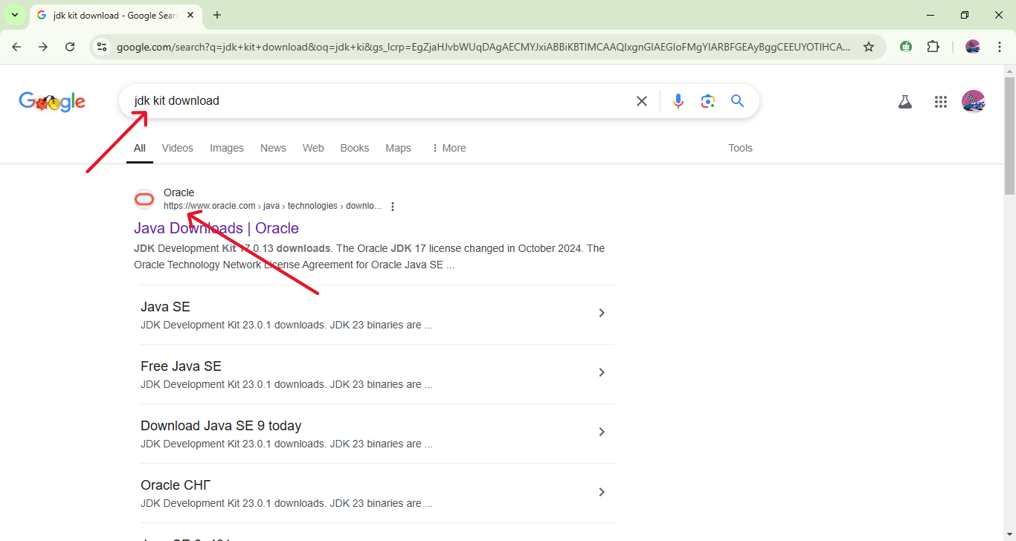

**Step 2:** Once you are in the oracle website, scroll down and select your operating system. The options are linux, Mac and Windows.

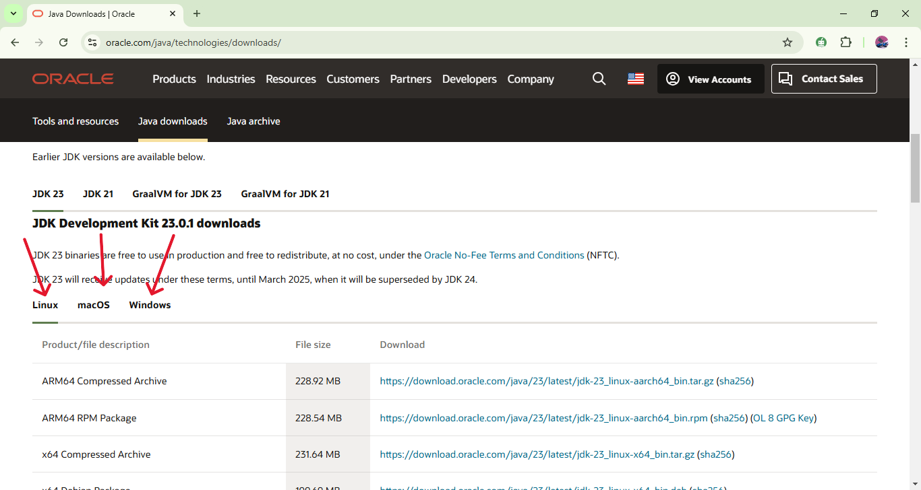

**Step 3:** After selecting your Os, choose and click on the x64 bit installer and there your download will automatically start.

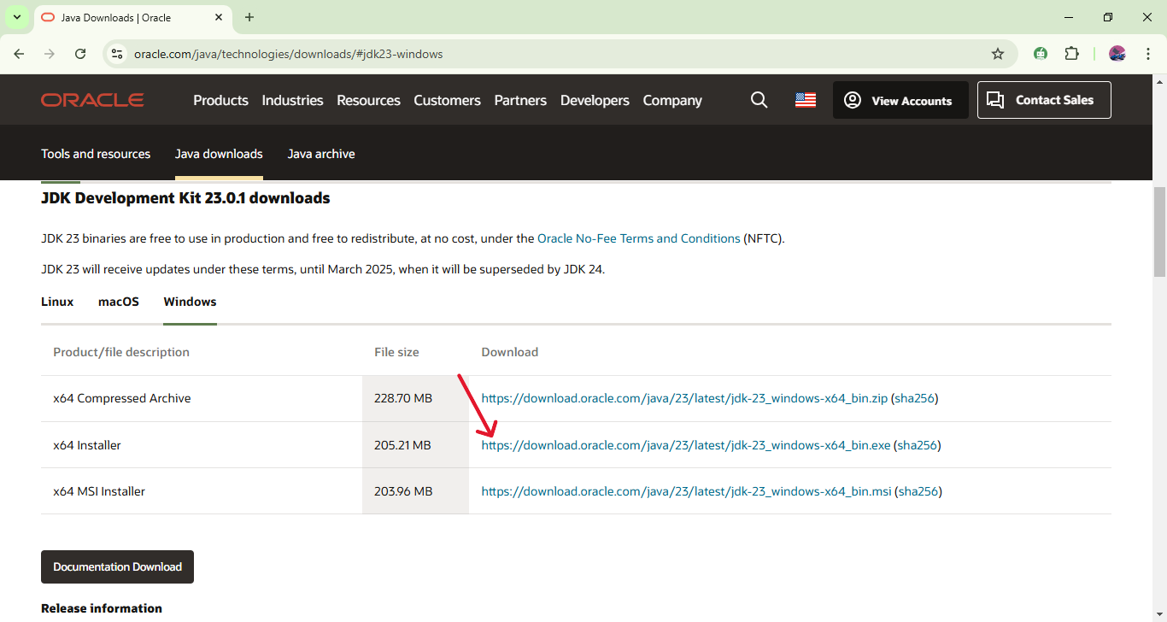

**Installation process:**

Navigate to your download, and click on the downloaded JDK exe file and it will directly take you to the installation wizard. On the installation wizard, click on next, another window will pop up where you also click next to finish installing the JDK to your computer.

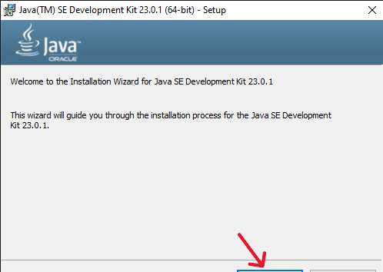

Click on next and wait for the registration process to complete. After completing the registration process, it will notify you that the software have been successfully installed, and you may close the window.

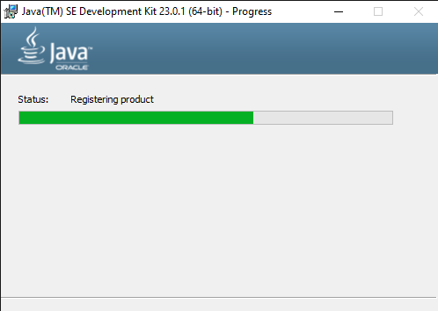

**Adding JDK to system path:**

**Step 1:** Click on your local drive, for **example “drive C”**, navigate **to “program files”,** in the program files, find **“java”** and click on it. Click and open **the “JDK-23”** folder and find the folder called **“bin”** double click on bin and a list of JDK files will appear. Click on the bar next to the dropdown icon on the top right corner once to display JDK path, and then copy that path.

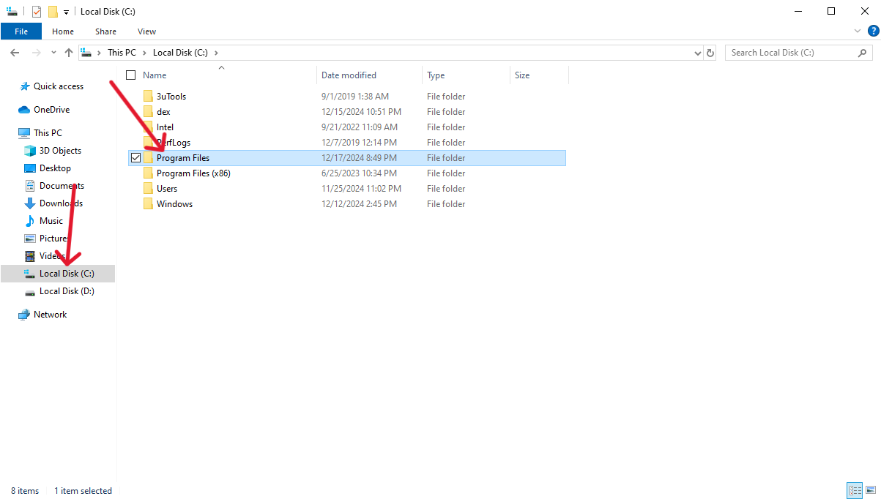

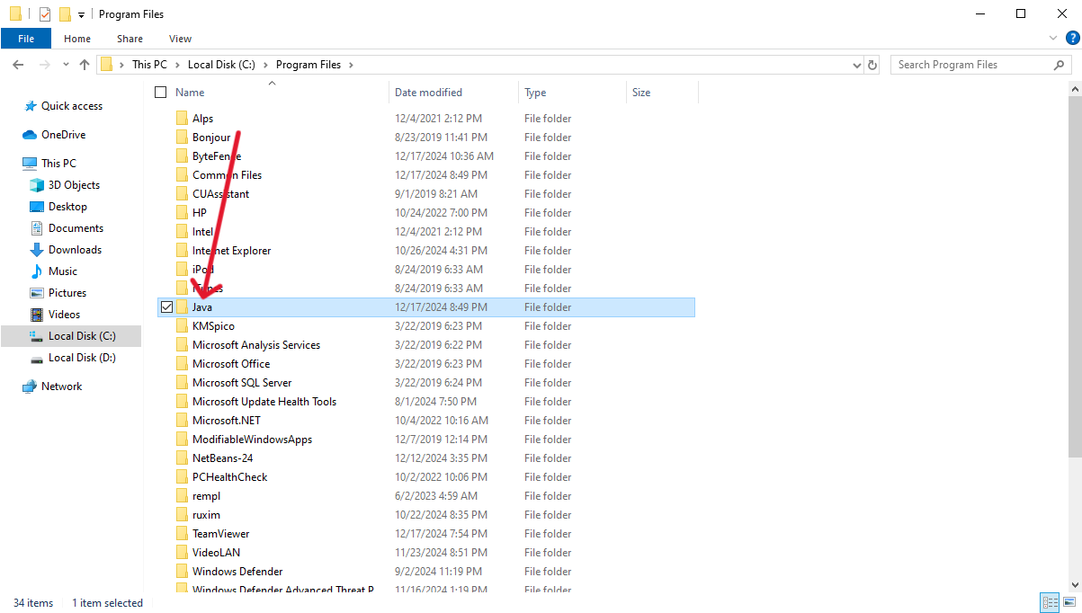

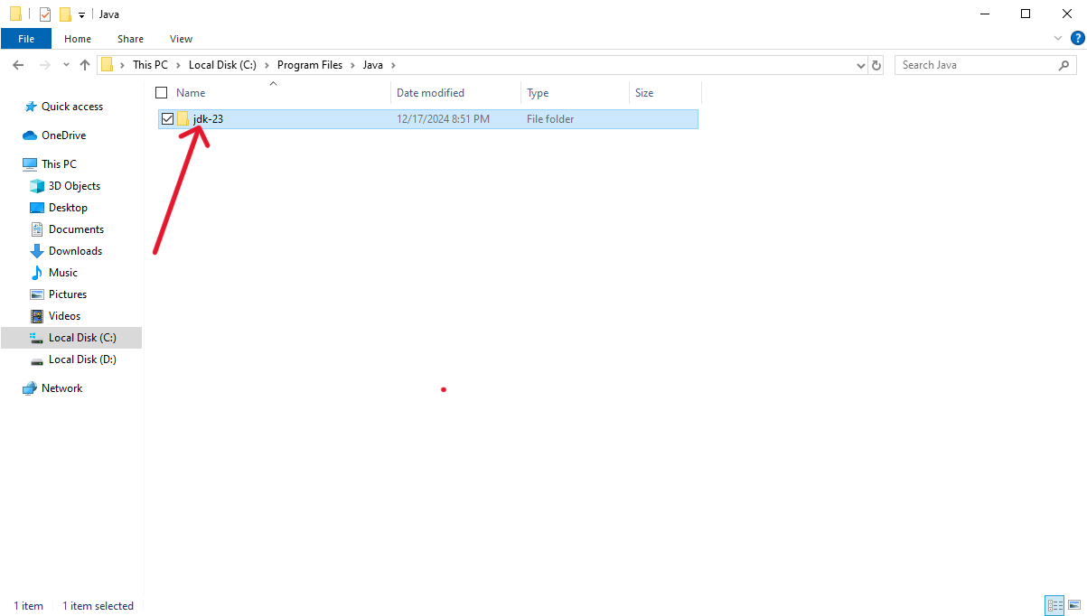

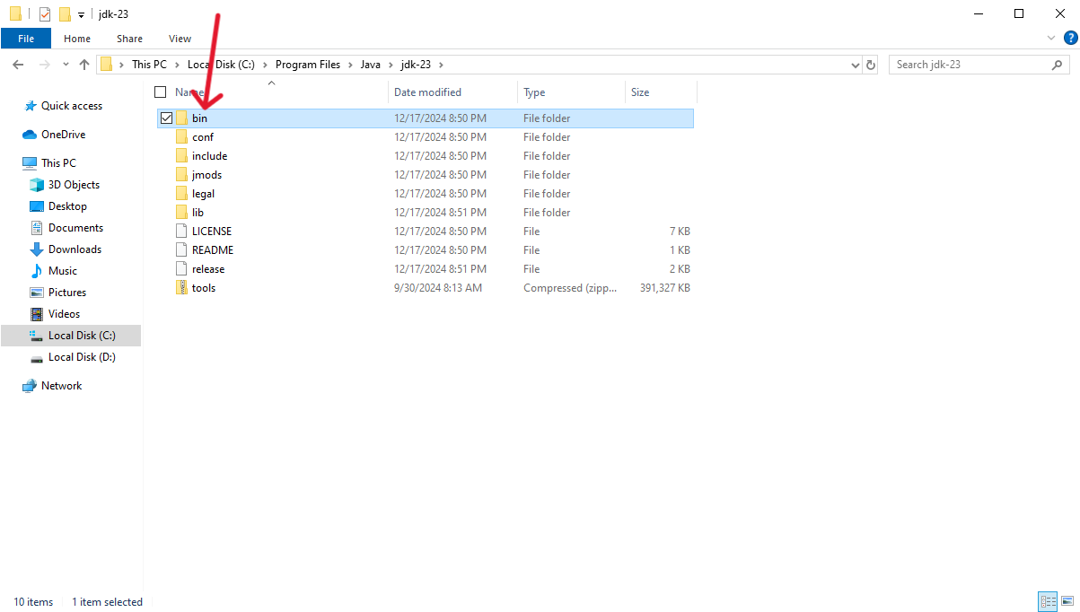

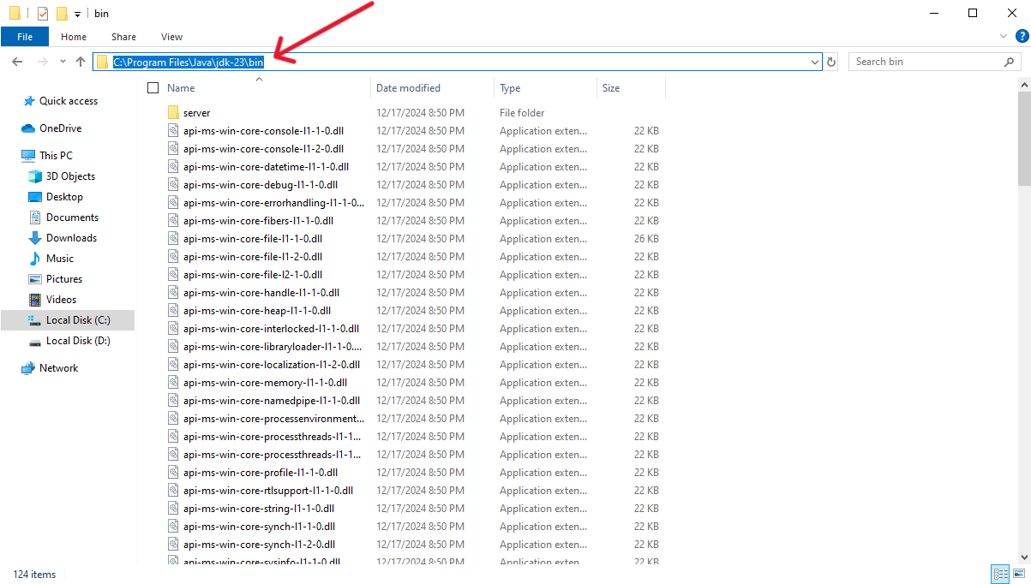

**Step 2:** Open settings and type **“edit the system environment variables”** and hit enter. A window will pop up. Under the advanced tab, click on **“environment variables”.** Under the system variables, click on **“path”** and then **“edit”.**

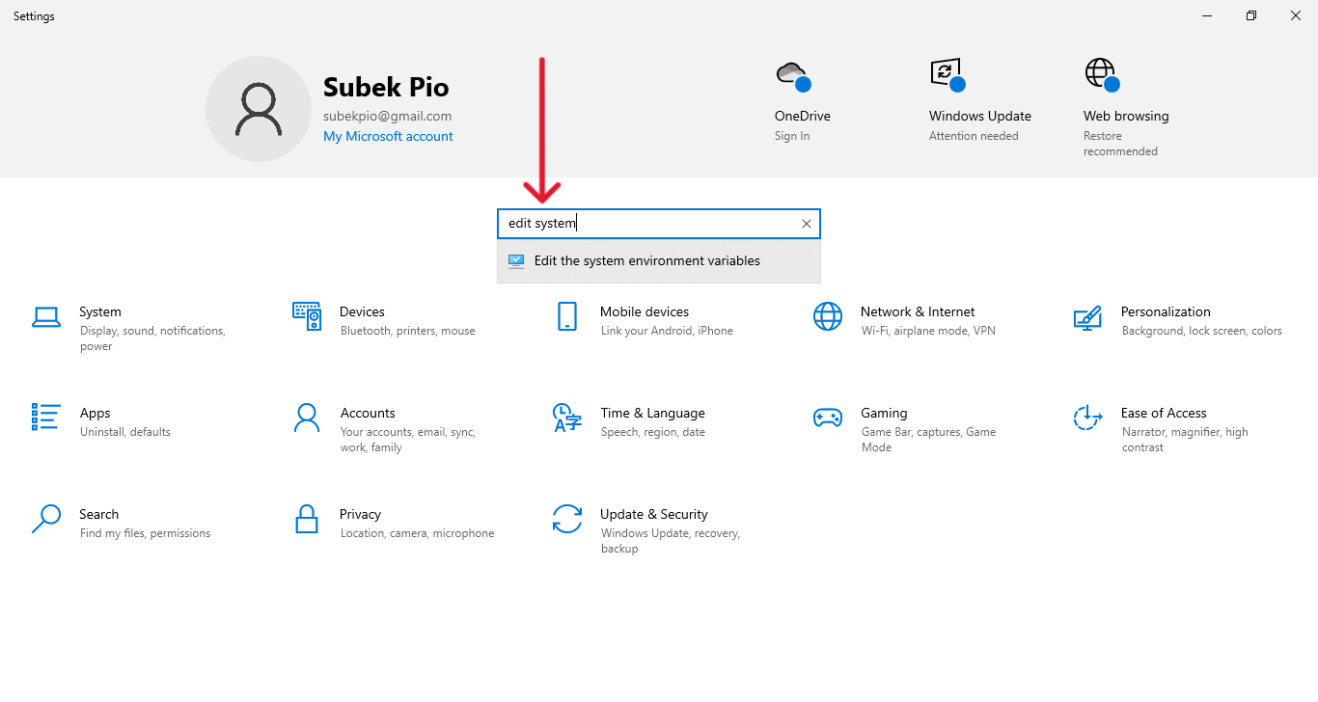

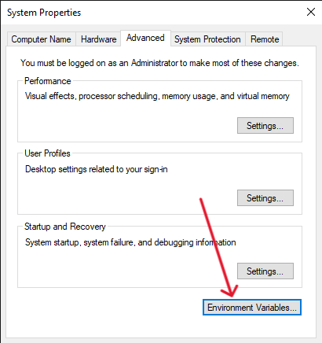 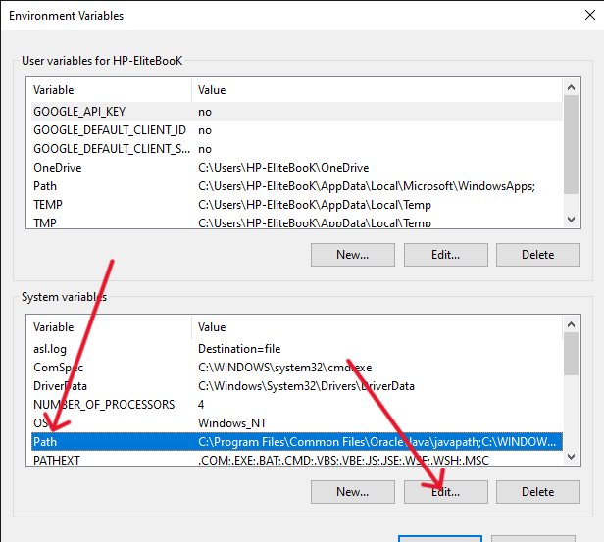

In the next window, click on “New” and past the JDK path you copied before. Then click on **“ok”** on every open windows.

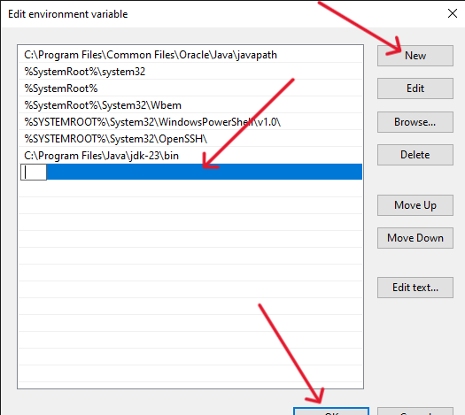

Check whether java is available in the computer:

Open the command prompt by clicking the windows key and type cmd for windows users, command + space and type terminal for mac and click on the enter key.

In the terminal, type the following command

**“java –version”** and you will see the version of your JDK being displayed as follows.

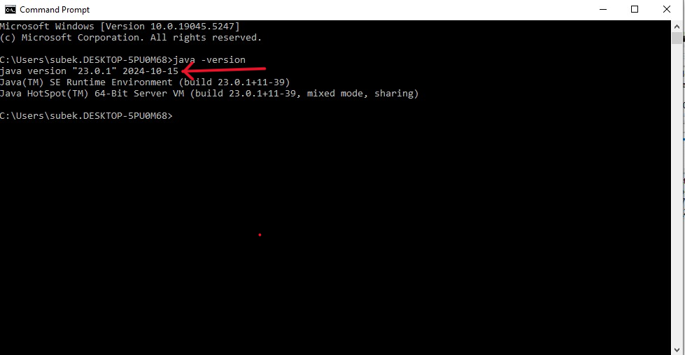

Downloading netbeans:

Open the browser and type “netbeans download”. Click on the first link “netbeans.apache.org”. In the next page, click on the download button under latest. In the next page under installers and packages, click on the first link for the x64 bit executable file. On the last page, you now click on the first link to start your download. After finishing downloading, you can install the netbeans.

